Course project report

In this project, consider the data set it have 9 attributes and between A~G have 3 types of value, and the class also have 3 type, so decide to use naïve Bayes to predict the class.

In this program, the first is load the training data from the excel file, using random method to divide the training data to two part, one is training set and 100 data for test set to test the accuracy, also the training method is to calculate the possibility of each different condition, save the value into a dictionary.

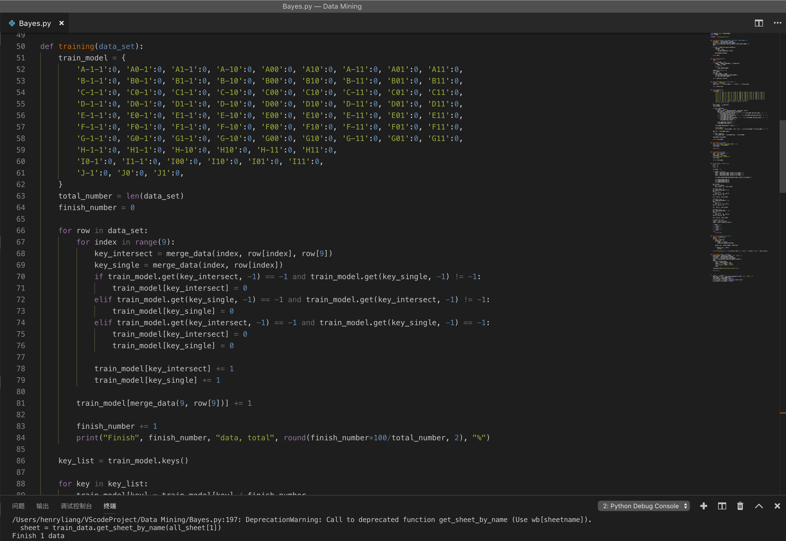

Then, by the naïve Bayes to calculate the possibility of -1, 0 and 1, compare the biggest possibility and return that value to be the predict result.

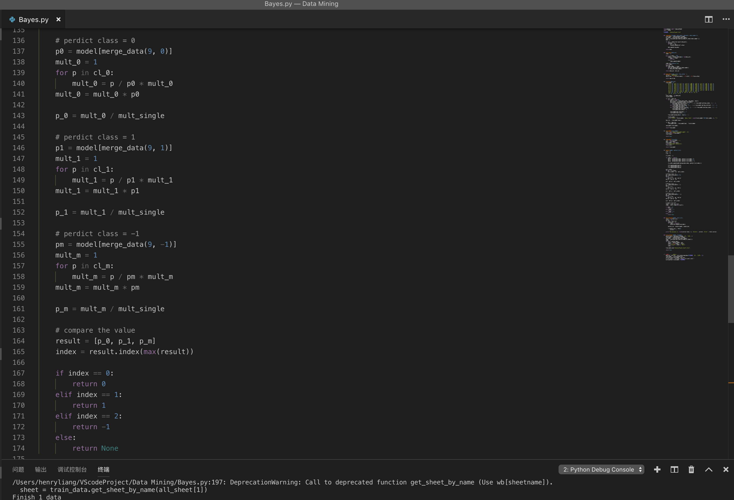

In the accuracy method, it will use the test set to test the accuracy of the possibility of the training model after each time the training finish, also will print it on screen.

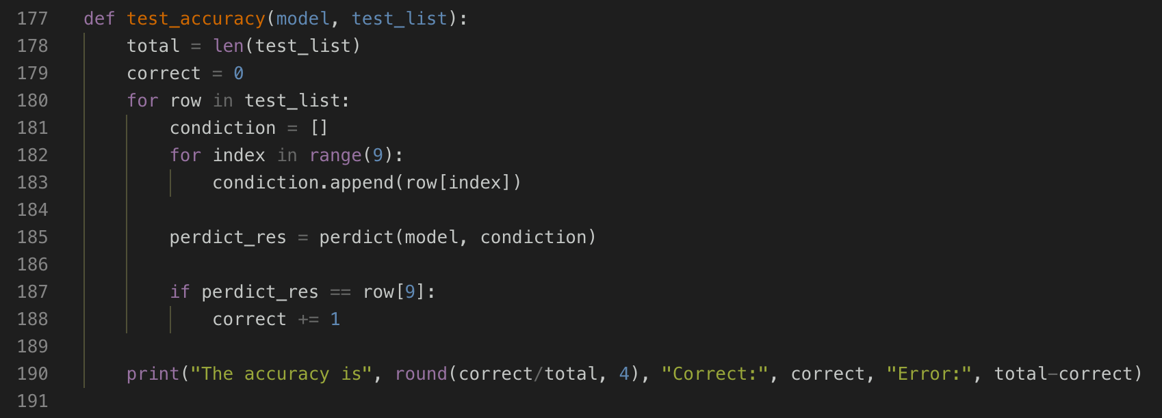

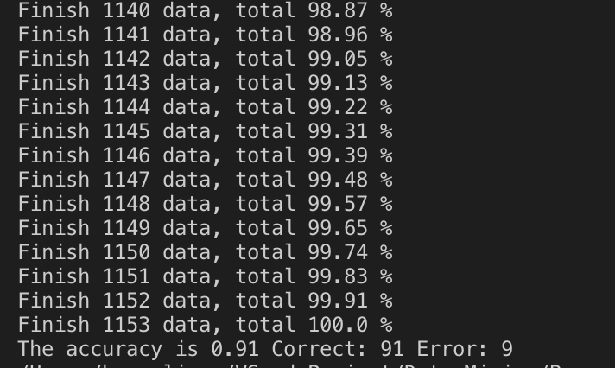

The next Is save the model and use it to predict the class in the test sheet and output the excel file in new name, in order not to cover the current file.

